- ResponseEntity is not sent to global ResponseHandler (having @RestControllerAdvice and implementing ResponseBodyAdvice)
- If you write the entity name User, it’ll not create because Postgres has its own user table where it maintains the user records.
  - So, better to write users in the @Table annotation.
  - 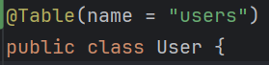

- If you are writing a method for doing some transaction in
  - If the method is private, then it’ll not be saved in the database after the end of transaction. To save, you need to mention repository.save() explicitly.
  - Or, even if the method is public but you are calling this method from some another method of same service (i.e. both normal method and transactional method is written in save service class) then also it’ll not save. Here also you need to mention repository.save() explicitly to save in the database.

- F

- Custom Annotation
- If you want to take an array as input to the annotation then write like the below
  - 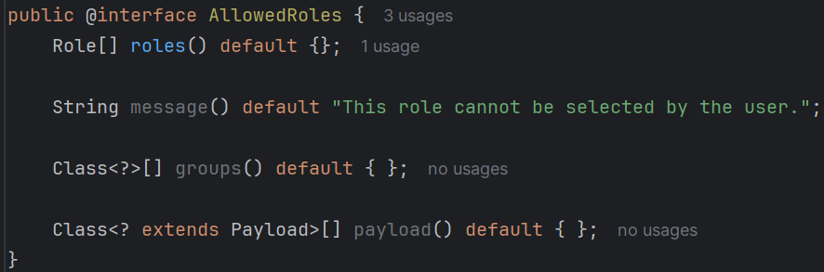
  - 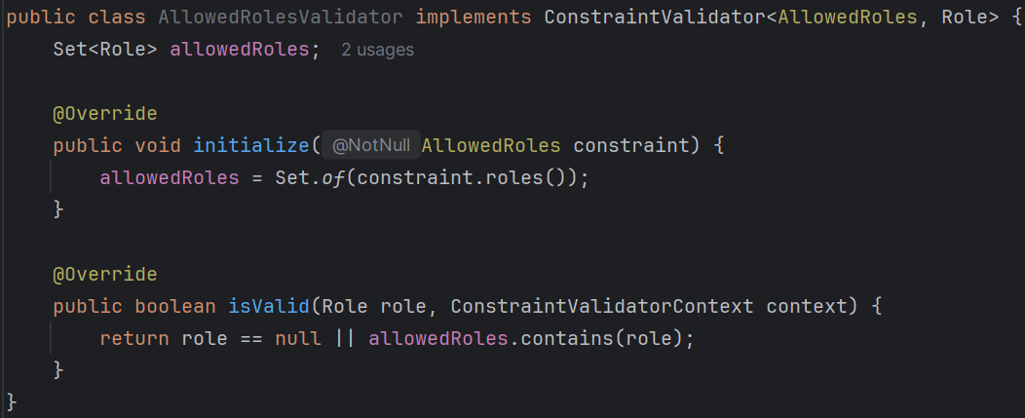
- Now you can use like this
  - 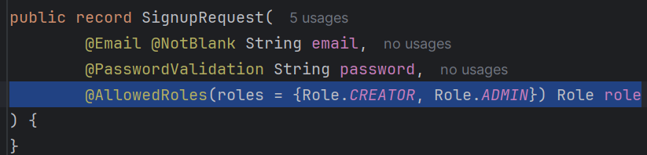
- You can see, we need to mention roles here explicitly, if you don’t want that then replace the name with value in place of roles
  - 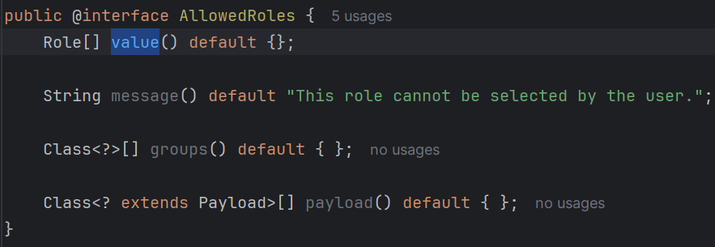
  - 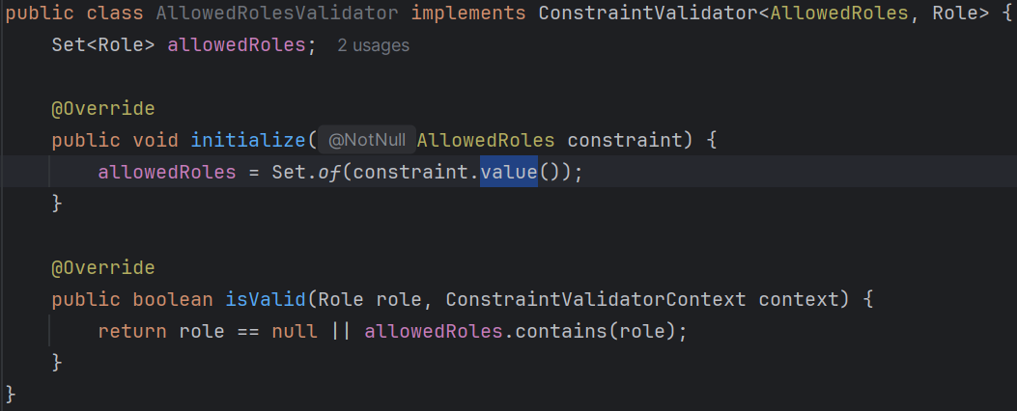
- And now you can call like the below without mentioning value explicitly.
  - 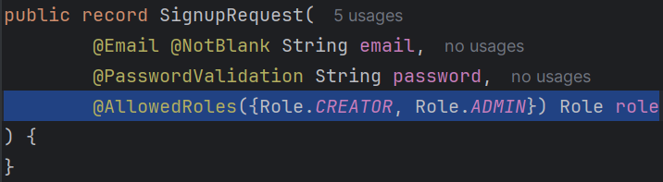
- If you want you can mention value as well like the below
  - 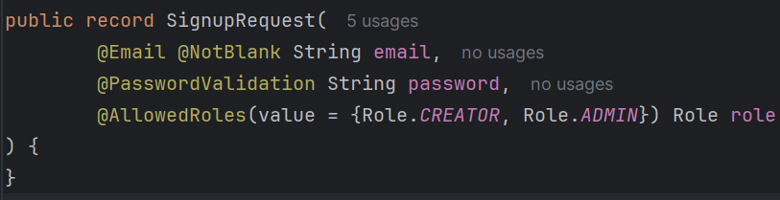
- Means, if the variable name is value then you don’t need to mention it explicitly while using the annotation.

- While logging in, don’t pass the user object inside the UsernamePasswordAuthenticationToken object like the below ❌
  - 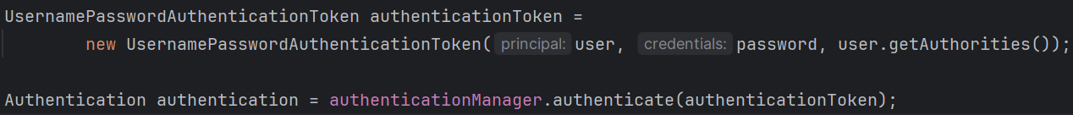
  - You shouldn’t do that; it’ll pass but still you should only pass email and password.
  - And inside JWT filter, you can add user in the principal; there is no issue here.

- By default the onAuthenticationSuccess method present inside SimpleUrlAuthenticationSuccessHandler class is used for handling success.
  - So if you make the session STATELESS then it’ll not redirect it automatically after authenticating.
  - But, if you override that onAuthenticationSuccess method then it’ll be redirected.

- F
- F

